Project Report

Data Science project: Factors Impacting USA Accidents and impacting severity of accidents.
Objective / Problem statement: The project is to use data science tools and techniques to build predictive modelling for a countrywide car accident dataset that covers 49 states of the USA. The accident data was collected from February 2016 to March 2023.
Motivation: Road accidents are a safety concern and can be life threatening or lead to permanent disability. A right analysis can help the police authorities to rightly allocate their resources, the government to plan some specific infrastructural opportunities and bring some regulatory changes. It can also help other stakeholders like business hubs to make specific changes to further help in ensuring employee safety as is further inferred in our report.
Scope of the project: We have focused on two main topics following the basic data cleaning and data preparation. First, we conducted exploratory data analysis to find various patterns in the data and check relationships between various attributes of the data using univariate, bivariate, and multivariate analysis.
Data overview:
The source of the data is from Kaggle: US Accidents (2016 - 2023). The data has 7728394 unique values i.e. circa 7.7M values. The data is rich with a wide range of data point spanning across multiple areas as
Weather data, Infrastructure data, Demographic data, Time Series data etc.
The data also has a few missing columns like End Latitude and End Longitude amongst others

Project Methodology
We followed the commonly used data science problem solving method as discussed in the lecture.
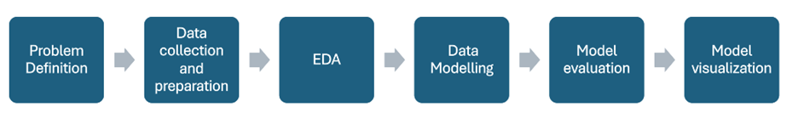
Data preparation / Data cleaning:
- Identification of null values and appropriately treating them.
- Processing of the time columns.
- Preprocessing Zipcode column based on the latitude and longitude section.

Data Exploration / EDA
Bivariate analysis with accidents during the day of the week and time of the day.

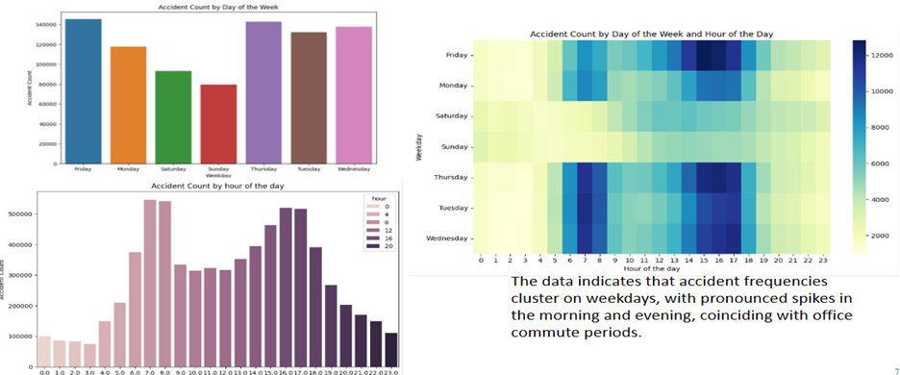
A density map to further locate the hot spots of the accidents was understood. This really helps in zooming the right zones within the country which are high-accident prone.

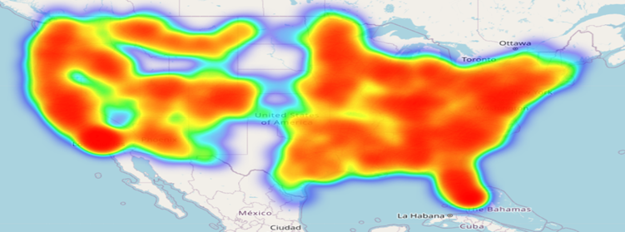
Link to heatmap:

Data Modelling:
We used an ensemble model with Logistic Regression, Random Forest, and XGBoost with the target variable as severity. The objective of this project is to predict the severity of the accident under varying input conditions to further help the traffic regulators and government authorities to better respond to these impacting parameters resulting in the accident.
Also, to understand the contributions of various factors towards severity of accidents.
The Steps followed in modeling are as follows:
- Target Variable Selection: Severity of accidents
- Data Transformation: Standard scaler, One hot Encoding, Binary Encoding
- Feature Engineering: Based on Feature Importance from Random Forest Classifier
- Data Splitting: Applied train (Jan 2020 to Dec 2021) vs Validation (Jan 2022 to Dec 2022) vs Test (Jan 2023 to Mar 2023)
- Data Balancing: “Smote” on our dataset to do some oversampling
- Model Selection: Meta(Logistic Reg. + RF + XGB), Final estimator: Multi-nominal logistic regression
- Model Evaluation: Accuracy & F1 score
- Model Deployment & Result Output: Streamlit to show severity class and contributions from features
Link to streamlit app: Streamlit
Below is the complete pipeline:
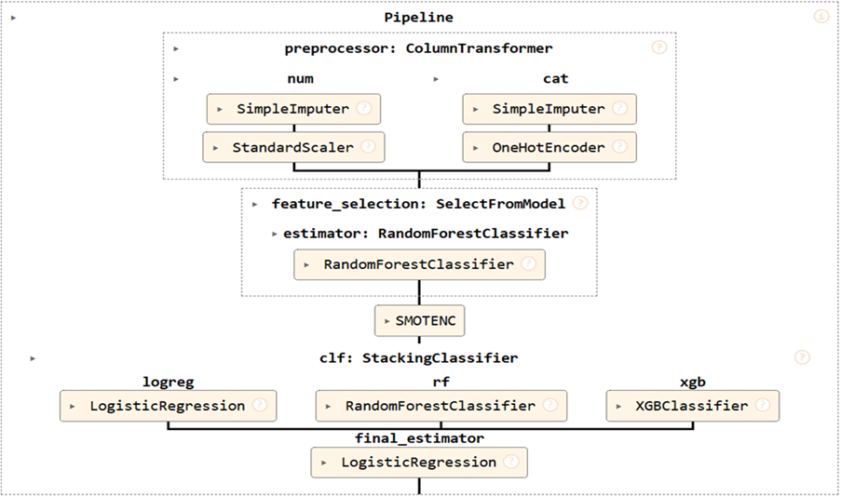
Business Recommendations (top ones):
- People should driver carefully during winter in month Nov, December, January.
- If the weather conditions are cloudy or partially cloudy cars should be monitored carefully.
- The Road Junctions should be monitored carefully.
- During sunrise or sunset time cars should be tracked carefully and should be give guidance.
- In case there's no traffic signal severity is high to get an accident. So, try to install signals in most of the sensitive sections of roads.
- Deploy more strict vigilance over the traffic during peak office commute hours. Morning 7am - 9am and evening 4pm - 6pm.
- Offices can give flexibility for log in and log off to avoid the rush leading to accidents.
- Clinics / ambulances can be deployed in vicinity of the red zones as per the heat map to optimize use of the healthcare services and ensure quick treatments.
Challenges & Solution:
- We observed a lot of class imbalances in the data with the most accident severity from class 2.
Solution: We used the ‘smote’ approach along with Stratified sampling to handle this imbalance in the data. Also, we took the help of “stratified” sampling as well to reduce records from data and get data from all classes.
- Another issue we faced was regarding the mixed data types across all 46 columns. These were either Boolean in nature or categorical objects.
Solution: They were handled by applying
- Selection of models is also a challenge because of less accuracy.
Solution: We eventually moved to an ensemble model to best the best accuracy. That increased the run time eventually.
- Overall, the runtime was high because of the big data size.
Solution: We discarded some historical data points and applied some sampling to reduce the data size and then to reduce the total runtime.

Possible Future improvements:
- A full version of app with full data sets.
- Addition of more classes in target variable
Contributions from each member:
Data Cleaning & EDA: Ninad Phadnis, Umesh BP
Feature Engineering & Pre-processing: Madipally Bhagath Chandra, Roupyajay Bhattacharya
Modeling & Evaluation & Deployment: Roupyajay Bhattacharya, Madipally BhagathChandra
Integration & Reporting, Presentation, Canvas: Umesh BP, Ninad Phadnis

All the files and codes are present at this path: https://github.com/umeshbp-iisc/ds-us-accidents-analysis
References:
GeeksforGeeks article on EDA with NumPy, Pandas, Matplotlib, and Seaborn. [geeksforgeeks.org]
Pandas: For data manipulation and analysis.
Matplotlib (and Seaborn): For visualization
Python Folium: Create Web Maps From Your Data – Real Python
1.11. Ensembles: Gradient boosting, random forests, bagging, voting, stacking — scikit-learn 1.7.2 …

